This is a simple demo app, but you can already see the error there.

The video sometimes takes 10-20 seconds to reach 1920x1080 resolution.

when the internet speed fluctuates, the same thing happens. And this is a problem for my application.
1:23 PM
Ok. I'll fix it perfectly.
1:24 PM

I left an online version if you prefer to test: https://webrtc.negrisoli.net
1:24 PM
If I finish it, do you have any other project?

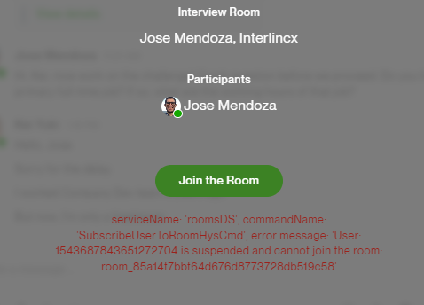

I broadcast video in a webrtc project. Everything works fine, but when connecting, it takes a few seconds to reach 1920x1080 resolution. I need the transmission to start already in this resolution.

